Nursery Applications
Please be advised that the applications for Nursery school places for the September 2026 intake are now open.
The closing date to apply for a Nursery school place is Monday, 16th February 2026. You can apply on-line at:
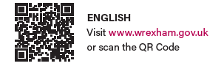
If you have made an application for a Funded Early Education place to start in January or April 2026, it’s important to note that this is not the same as a Nursery application. The 10-hour funded early education place is only for the spring and/or summer term and will end in July. Parents who applied for a January place will have already received their response letter. Parents who applied for an April place will receive their response letter on 19th February.
Securing a place in an early education setting for spring or summer term does not guarantee you a place at the same setting for the Nursery class which starts in September. You must make a separate application for the Nursery class if you have not done so already, and these applications are processed in line with our admissions policy.
If you have any difficulties in making an application, please contact us at admissions@wrexham.gov.uk or 01978 298991.

